# Front End Technologies Week 7 Coding Assignment

**Points possible:** 75  
  
**URL to GitHub Repository:**

[**https://github.com/RKMellinger/Promineo/tree/main/Week-07-HTML/Week%20%207%20coding%20assignment**](https://github.com/RKMellinger/Promineo/tree/main/Week-07-HTML/Week%20%207%20coding%20assignment)

**Video Link:**

[**https://youtu.be/u5lXvvFd-dE**](https://youtu.be/u5lXvvFd-dE)

**Instructions:** In VS Code, or an IDE of your choice, write the code that accomplishes the objectives listed below. Ensure that the code compiles and runs as directed. Take screenshots of the code and of the running program (make sure to get screenshots of all required functionality) and paste them in this document where instructed below. Create a new repository on GitHub for this week’s assignments and push this document, with your project code, to the repository. Add the URL for this week’s repository to this document where instructed and submit this document to your instructor when complete.

**Coding Steps:**

1. Create a website using only HTML. The website can be anything you like (within school guidelines) as long as it meets the following criteria – website must contain:
   1. At least 3 pages
   2. Links to navigate between all pages present on each page
   3. A list
   4. 3 images
   5. 2 different size headers
   6. A table
   7. A form

**Screenshots of Code:**

**Main Page:**

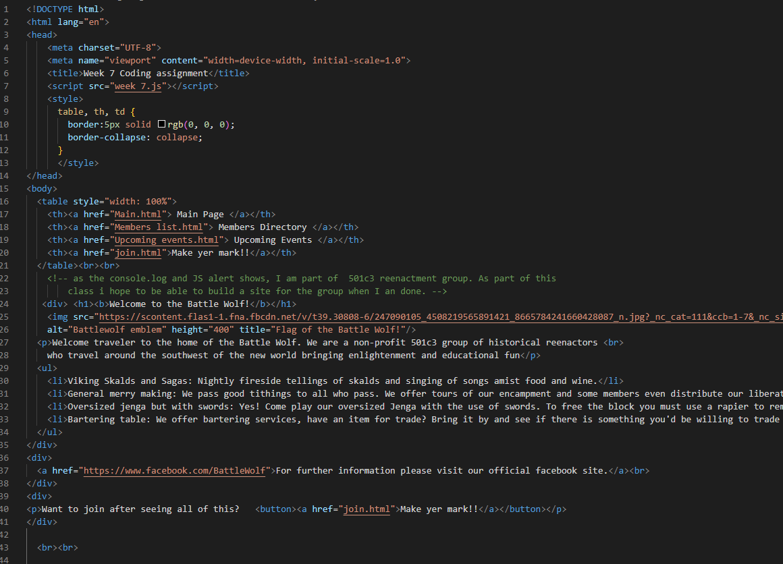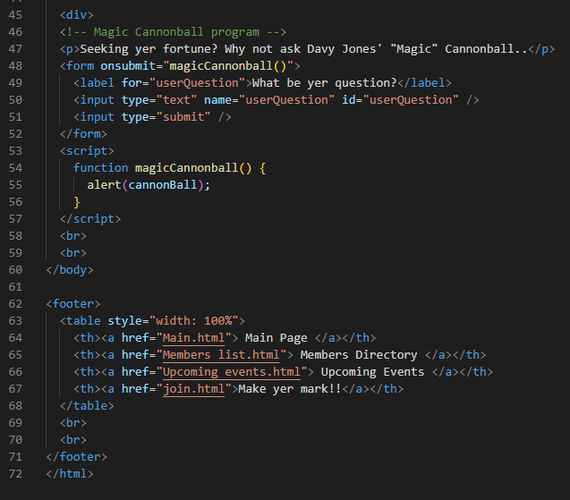

**Member Directory (page 2):**

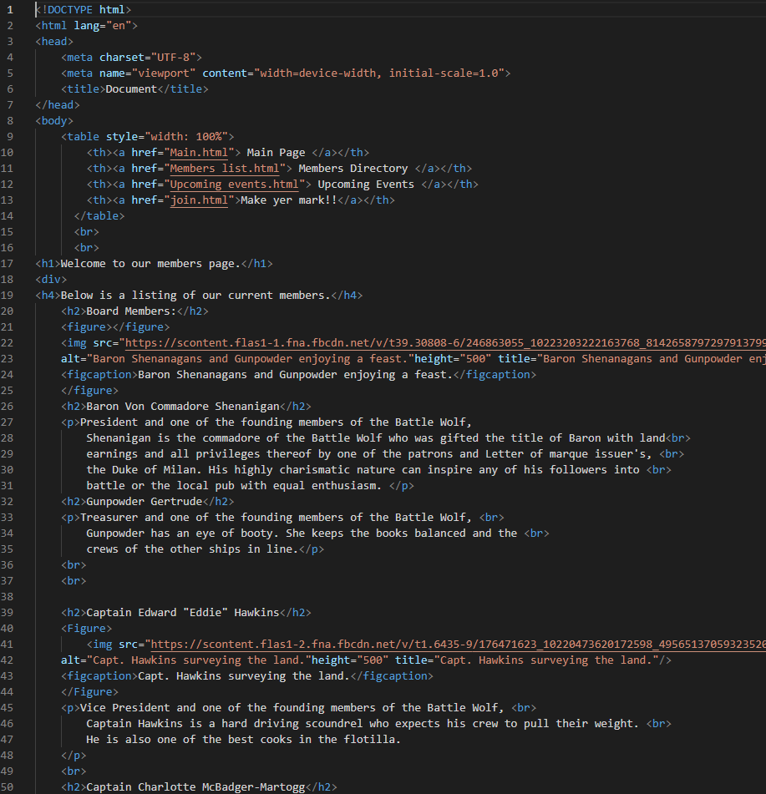 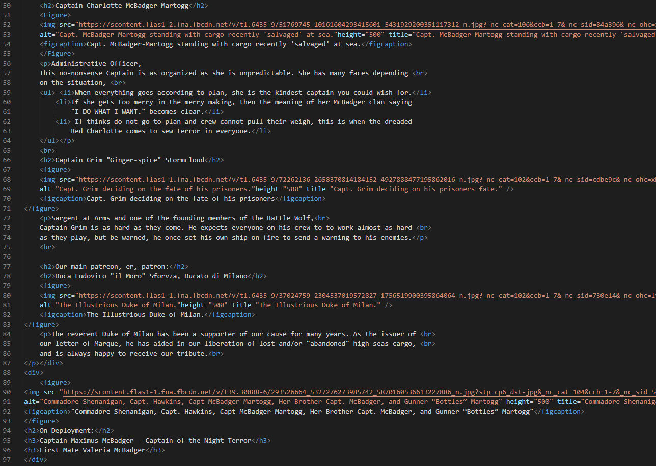

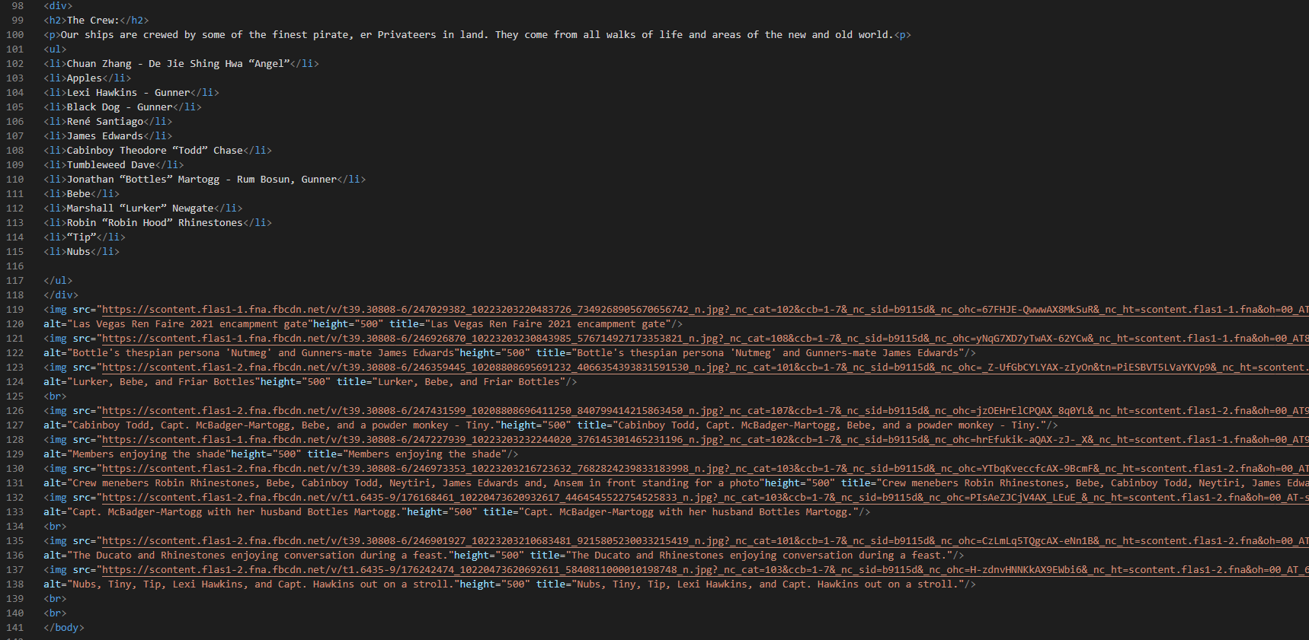

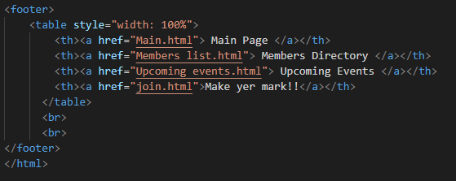

**Upcoming events (page 3):**

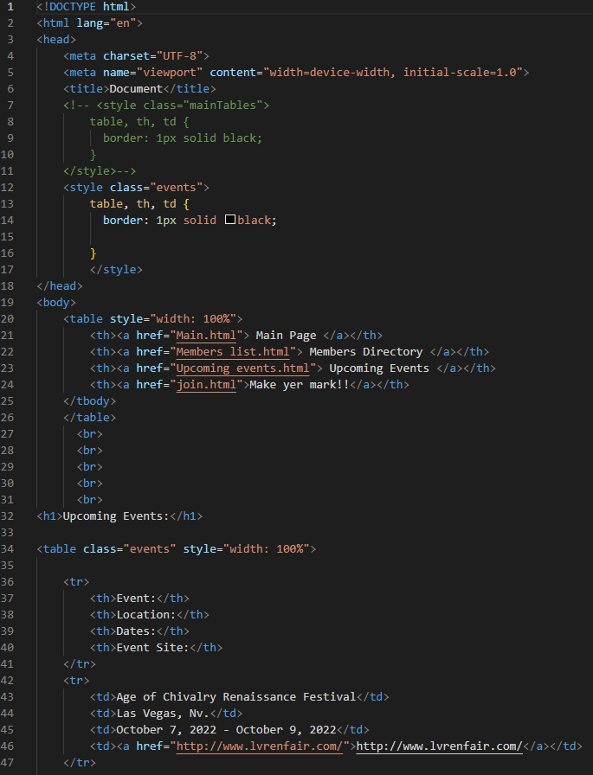 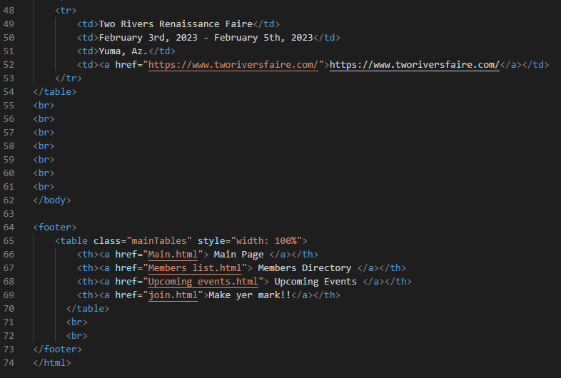

**Join up Form (page 4):**

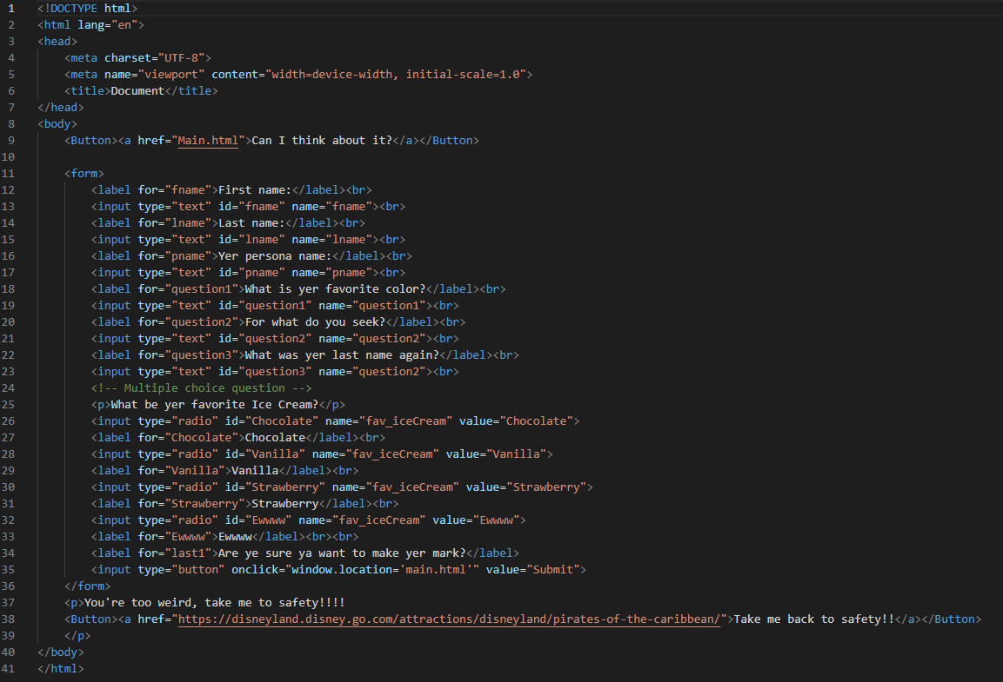

**Connected JS file:**

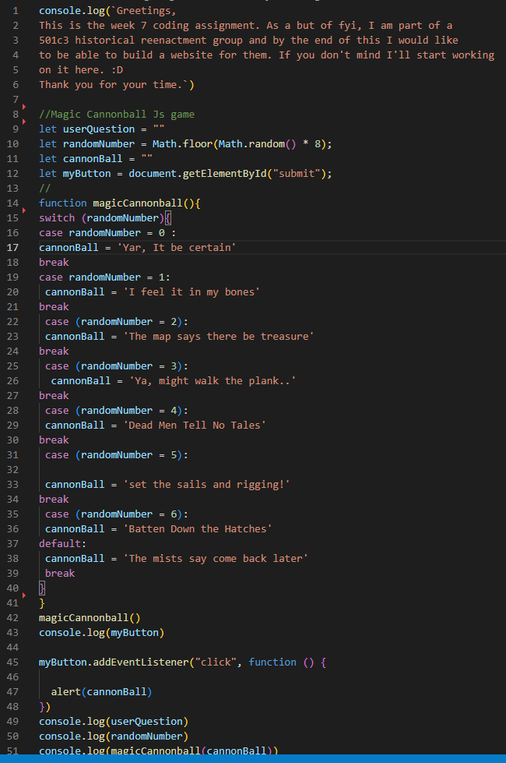

**Screenshots of Running Application:**

